
Year 7

__
40

=_________%

Mini Test 7

Name: ______________________________ Date: _________________
Show working and answers on this sheet. Show working in sufficient detail to support your answers. Incorrect answers without supporting reasoning may be allocated zero marks.

Equipment: Calculator and protractor
- Name each of these angles in two different ways. (2 marks)
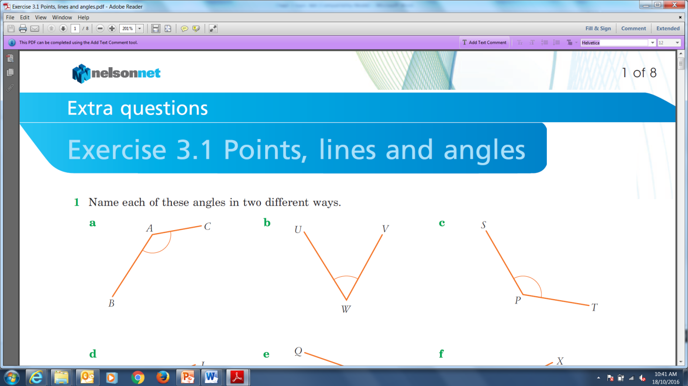
- b)

- The name of the angle marked X is which of the following? (1 mark)
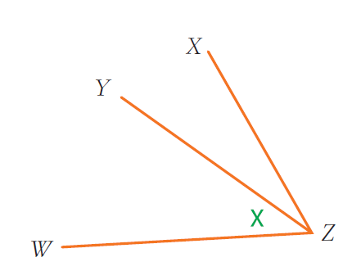

- $XZW$ b) $XZY$ c) $WYX$ d) $YZW$

- What is the size of the angle in the shaded triangle marked by the arrow? (1 marks)

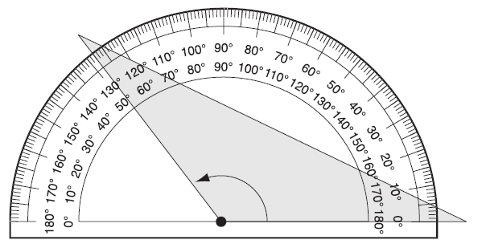

- Draw the following angles: (3 marks)
a) 120˚ b) 340˚

- Give an example of each type of angle underneath the name: (4 marks)
a) Acute b) Obtuse c) Reflex d) Revolution

- Find the value of the unknown: (9 marks: 1, 1, 1, 1, 2, 2, 1)
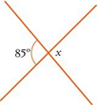
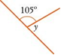
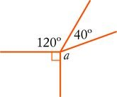
a) b)

c) d)
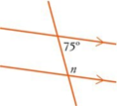
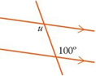

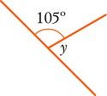

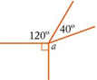
e) f)
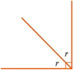

g)
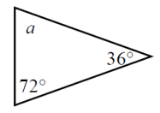

- A triangle has two equal sides and one angle of 98˚. What is another angle in this triangle? (2 marks)

- Complete the table below: (3 marks)
Decimal | Percentage | Fraction
0.12
 | 60%
 |  | $$\frac{2}{5}$$

- What percentage is 16 marks out of 20 marks? (1 mark)

- What is $10 as a percentage of $40? (1 mark)
a) 4% b) 10% c) 25% d) 40%

- Calculate 75% of 40 (1 mark)

- 20% of the 140 photographs at an exhibition were black-and-white. How many black-and-white photographs were there? (1 mark)

- Kyle won 17 games out of a possible 20. What percentage of games did he lose? (2 marks)

- The Maths class has 11 girls and 13 boys. (2 marks: 1, 1)
a) What is the ratio of boys to girls?

b) What is the ratio of girls to the total number in the class?

- Cordial concentrate is mixed with water in the ratio of 1 : 3. How much cordial concentrate is needed to make a mixture of 2L? (2 marks)

- Write each of the following as a rate: (2 marks: 1, 1)
a) Write $40 for 10 trees

b) 100 m in 10 seconds

- A water tank of capacity 80 litres takes 18 minutes to fill. At what rate is the tank being filled? (1 mark)

- A block of cheese costs $13/kg. How much would 2.2 kg cost? (1 mark)

- What type of quadrilateral am I? (1 mark)
I have 4 sides.
I have two pairs of equal sides.
I have two pairs of equal angles.
I have two pairs of parallel sides.

I am a _____________________

~End of Test~

